**Alphabet Soup Deep Learning Analysis Report**

The nonprofit foundation Alphabet Soup wants a tool that can help it select the applicants for funding with the best chance of success in their ventures. We have received a CSV containing more than 34,000 organizations that have received funding from Alphabet Soup over the years.

**Results**:

* Data Preprocessing
  + We use “Is Successful” as the feature variables for our analysis
  + The targeted variable for this analysis is we hope to see if the charity is seen as a successful target to invest for Alphabet Soup.
  + We removed EIN and NAME from the list to acquire a more cleaner list.
* Compiling, Training, and Evaluating the Model
  + Originally, we used 2 layers with 80 and 30 neurons. Then we added 3rd layer to make the neurons of 110, 80 and 30 to see if we can get different results.

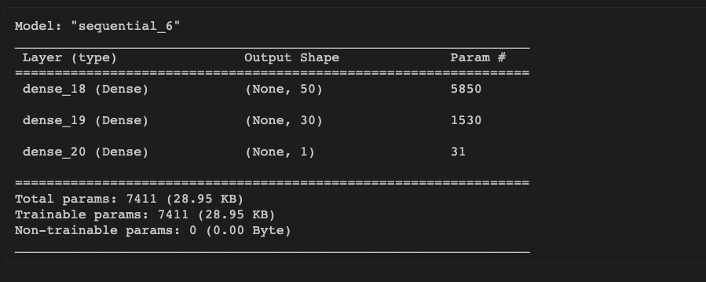

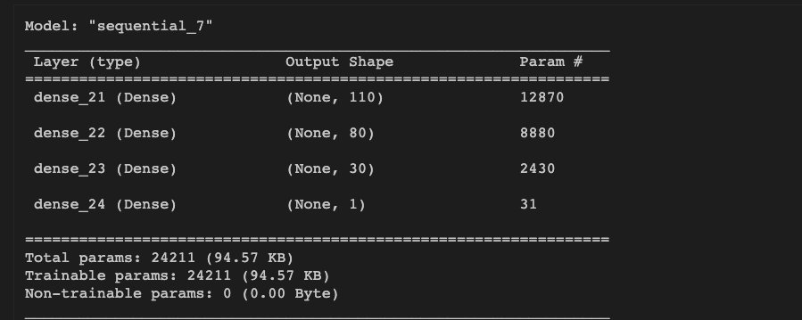

* + We could not reach the 75% target and we only achieved around 73%~72% accuracy.
  + We also tried to use different columns but it did not make the result with higher accuracy.

**Summary**:

We did not reach at least 75% accuracy with this method, even we tried to adopt a wide variety of adjustment. Maybe with more data and information, we can try other machine learning methods to do our comparison.